How to Download and Install WPML

**You can download and install WPML manually, by downloading ZIP files from your WPML.org account, or automatically, via the Plugins admin screen.**

Manual Download and Install

In case you want to install WPML manually, follow these steps:

1. Log in to your [WPML.org account](https://wpml.org/?page_id=5840).
2. Go to the Downloads section.
3. Download the [WPML components](https://wpml.org/documentation/wpml-core-and-add-on-plugins/) that you need.
4. Unzip each file. A directory will be created.
5. Upload the unzipped directories to your site’s ‘wp-contents/plugins’ directory.
6. Log in to your site, go to Plugins and enable them.

You should note that manual installation will require to download all of WPML’s components and repeat this process for every upgrade.

Manual install is useful if your site is running on a private network, with no access to the Internet, or if you’re using your own scripts to manage plugins across a network. Normally, you should use the automated install, described next.

Automated Installation (recommended)

**WPML uses the**[**Installer**](http://wp-compatibility.com/installer-plugin/)**plugin for automated, safe and easy installation. There’s a one-time setup process, described below. After this setup process, WPML downloads and upgrades will automatically appear in your site’s Plugins section.**

1. Go to [Installer plugin page](http://wp-compatibility.com/installer-plugin/) and download from there.

2. Unzip Installer and upload to your site’s ‘wp-contents/plugins’ directory.

3. Log in to your site, go to Plugins and enable Installer.

4. Go to **Settings->Repositories**, locate wpml.org repo and log in to your account.

A window will open, asking for your login details.

**[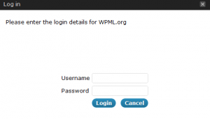](https://d2salfytceyqoe.cloudfront.net/wp-content/uploads/2012/08/wpml-org-login.png)**

Log in to WPML.org

Log in to your WPML.org account, with your username and password. We’ll save your details encrypted and use them whenever there’s an upgrade to WPML, to get new versions automatically.

5. Once you are logged in, click on ‘**Install plugins from WPML.org**‘. You will see all of [WPML’s components](https://wpml.org/documentation/wpml-core-and-add-on-plugins/)(there are several results for WPML, you may need to scroll down to see all of them).

[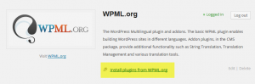](https://d2salfytceyqoe.cloudfront.net/wp-content/uploads/2012/08/download-wpml-plugins.png)

6. Next to each of WPML’s components, there’s a link to either ‘Install Now’ or ‘Installed’ (if it’s installed already). Click on Install Now for the components that you need.

[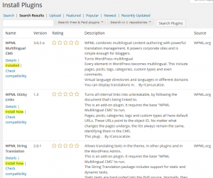](https://d2salfytceyqoe.cloudfront.net/wp-content/uploads/2012/08/install-wpml-components.png)

*Note: if you purchased Multilingual Blog, only base WPML plugin will be available to download (WPML Multilingual CMS). You’ll see ‘upgrade’ links next to the other components.*

Click on the **Install Now** links to download and install WPML.

Of course, for all this to work, you need to have an account in WPML.org. With every purchase, you receive a year of upgrades and support and you can use WPML on as many sites as you like.

# Language Setup

The languages section allows you to turn a WordPress site multilingual.

To manage languages, go to **WPML->Languages**.

## Site Languages

## [Choosing languages for the site](http://d2salfytceyqoe.cloudfront.net/wp-content/uploads/2009/03/languages_wizard.png)

When you configure WPML for the first time, you need to choose the language of existing content. Then, add more languages to the site. You can always go back to add / remove languages.

If you need to use a language that doesn’t appear on the list, click on “Edit languages” and create it.

## Language switcher

To let visitors select their language, you can add a language switcher to your theme.

WPML’s standard language switchers include a **drop-down languages list**, a **list of languages for the site’s footer** and a **language switcher in the menu**.

[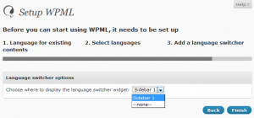](http://d2salfytceyqoe.cloudfront.net/wp-content/uploads/2009/03/language_widget.png)

WPML can enable the language switcher widget automatically for you as a widget in one of the sidebars.

For complete information about different styles of language switchers that you can add to your site, please read about [language switcher options](http://wpml.org/documentation/getting-started-guide/language-setup/language-switcher-options/).

Alternatively, you can add with via the Widgets screen or manually to your theme using the following PHP code:

<?php do_action('icl_language_selector'); ?>

### Choosing what to display in the language switcher

You can choose what to include in the language switcher. WPML can display a country flag, the native language name and the language name in the page’s language.

You can also choose colors for all parts of the language switcher.

[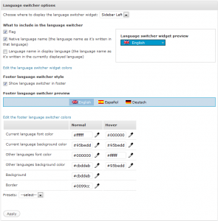](http://d2salfytceyqoe.cloudfront.net/wp-content/uploads/2010/02/language_switcher_with_footer.png)

### Order of languages

You can control the order in which languages appear in the language switcher. Look for **Languages order** in the Languages settings page.

[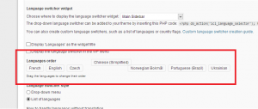](http://d2salfytceyqoe.cloudfront.net/wp-content/uploads/2013/03/languages-order.png)

You will see a list of the languages in your site. Drag them around to change the order.

Please note that when you use a drop-down language switcher, the first language shown is always the current language. The other languages will be listed according to the order that you set in the **Languages order** list.

The footer language switcher will always display with the ordering that you specify.

### Customizing language switchers

Of course, you can [style WPML’s language switcher](http://wpml.org/documentation/getting-started-guide/language-setup/styling-the-drop-down-language-switcher/) so that it matches your site’s design. You can also create[custom language switchers](http://wpml.org/documentation/getting-started-guide/language-setup/custom-language-switcher/) and add them to the site’s theme.

To change the flags that appear next to languages, click on “edit languages”. You can choose a different flag from WPML’s install directory or upload your own.

### Language URL format

WPML lets you choose how to organize contents in different languages. You can select between:

* Language directories (like wpml.org/es/ for Spanish and wpml.org/de/ for German).
* Different domains per language
* A language parameter added to the URL

For language directories to work, your site’s permalink structure needs to be different than the default one. We recommend choosing Year/Month/Name.

Different domains per language requires configuration in your server’s DNS and Apache configuration. Read the  
[Server setting for languages in different domains FAQ](http://wpml.org/faq/server-setting-for-languages-in-different-domains/) for a complete tutorial.

## 

## Admin language

The default language is normally also the admin language. To see the WordPress admin in a different language, use the **Admin language** setting.

Websites that have several authors, each writing in a different language may need to have a different admin language per user. Individual users can select their admin language in their profile page.

To learn how to set the site’s default admin language and different admin language per user, read about[setting the WordPress administration language](http://wpml.org/documentation/getting-started-guide/language-setup/setting-the-wordpress-administration-language/).